A
project REPORT
on

SECTION MAINTENANCE SYSTEM



Bangladesh University of Business & Technology (BUBT)
Department of Computer Science & Engineering

Submitted to:

Md. Kamruzzaman
LECTURER
Department of CSE

Acknowledgements

First and foremost, we are grateful to the Almighty Allah, the Merciful without whose patronage and blessing this project would not have been successfully completed. He gave us zeal, confidence, power of determination and courage and vanquished all the barrier that we have faced on the way.

It is an moment for us as student of dept. of Computer Science & Engineering one of the prestigious academic center Bangladesh University of Business & Technology (BUBT) to express our deep feeling of gratitude to dept. and especially our honorable course teacher Md. Kamruzzman, lecturer, dept. of CSE for his wonderful guidance and inspiration.

The work could not be finalized without his astute supervision. We pay profound regard to all of our teachers and also pay regard to our friends in the dept. who, through their interest and work are our contestant source of inspiration.

Declaration

I hereby declare that the project entitled ”section maintenance system ”is submitted in partial fulfillment requirements for the course of Software Engineering in the faculty of Computer Science & Engineering in Bangladesh University of Business & Technology (BUBT) .
It is authentic record of our own work carried out at under the guidance of our Course teacher .

Zahid Ahmed Jamal Uddin
Id -15162103067 Id – 1314210303
- M. Mamunur Rashid Sumi Karim
Id -13142103040 Id- 15162103052

Table of Contents
- Introduction of the Project
  - Background of the Study
  - Statement of the Problem
  - Project Objectives
  - Scope of the Project
  - Constraint of the Project
  - Project Deliveries
  - Software and Hardware Specification

- System Requirement Study
  - User Characteristics
  - Hardware Requirement
  - Software Requirement
  - Functional Requirement
  - Non-Functional Requirement

- System Analysis
  - Study of Current System
  - Problems and Weakness of Current system
  - Feasibility Study
  - Model choosing
  - Requirement and Analysis
  - Design
  - Coding/Implementation

- System Design
  - Introduction
  - DATABASE STRUCTURE MODELING
  - DATABASE DESIGN VIEW
  - TABLE STRUCTURE AND LIST WITH POPER DESCRIPTION

- Implementation Planning and Testing
  - Implementation Environment
  - System Implementation
  - Testing
  - Software Testing

- Diagrams
  - Context level Diagram
  - Use Case Diagram
  - E-R diagram
  - Data flow diagram

- Appendix
7.1 Screenshot of the project
- Conclusion and Discussion
  - Conclusion
  - Future enhancement
- References

Introduction of the Project
Section Management system is a management information system for education establishments to manage class and examinations related data. It provide capabilities for knowing class schedule, examinations schedule, assignment related information, to contact with course teachers etc. By developing this project, students can easily know about class and examinations information also can know the assignment submission date and its topic. We can summarize this in some point, they are:
- Students got Class Test & Quiz Test Schedule.
- Students can submit the Assignment in time.
- Students know the able to Class Schedule.

1.1 Background of the Study
The major benefit of this web portal is to store the section’s class schedule, examinations schedule, assignment, class-test, and quiz-test
Information at one place (like SERVER) and it can be accessed via online interaction. The Section Management System web portal is to replace the old and traditional file (paper work) storing process. Instead of tedious paper work, students will be able to get required information electronically, and the departments will be able to give the information’s with a much quicker turn around.

1.2 Statement of the Problem

Most of the students do not attend class regularly and they miss to know about their class-test or any quiz-test at most of the times. And often they do not check update of his class/examinations from their university’s website, they collects the information from their classmates. Here is a chance to get wrong information. So, the possible problems are given below:

- Students can’t attend the Class Test & Quiz Test.
- Students can’t take the preparation of Class Test & Quiz Test.
- Students can’t submit the Assignment in time.
- Students miss the class as they do not know the Class Schedule.

1.3 Project OBJECTIVES

Section Management System is a web-based application for students and teachers who want to get and retrieve class, examination, assignment etc whole information instantly via internet. The major benefit of this web portal is to store the section’s class schedule, examinations schedule, assignment, class-test, and quiz-test
Information at one place and it can be accessed via online interaction. The Section Management System web portal is to replace the old and traditional file (paper work) storing process.It provide capabilities for knowing class schedule, examinations schedule, assignment related information, to contact with course teachers etc. By developing this project, students can easily know about class and examinations information also can know the assignment submission date and its topic.

We can summarize this in some point, they are:
- Students got Class Test & Quiz Test Schedule.
- Students can submit the Assignment in time.
- Students know the able to Class Schedule.

1.4 Scope of project

The Section Management System web portal is to replace the old and traditional file (paper work) storing process.It provide capabilities for knowing class schedule, examinations schedule, assignment related information, to contact with course teachers etc.

- PROPOSED SYSTEM
By developing the system we can attain the following system: Students miss the class as they do not know the Class Schedule.
• Easy to handle and feasible
• Fast and Convenient

1.5 Constraint of the Project:
There are some limitations in this project. Although we have tried to make a successful project but there are some limitations.

- Due to security requirements Local user cannot use all utilities and modify system settings
- Not for mobile user

1.6 Project Deliveries:
The main deliverables of this project will be the complete system and the software engineering document that include –
-Application requirement and specification.
-Application design document.
-The software engineering document will be constructed.

1.7 Software and Hardware Specification:
Hardware specification:
-Laptop / Computer.
Software specification:
- windows xp/vista/8/10
- Notepad++ , xampp

Chapter – 2
System Requirement Study

2.1 User Characteristics
Basically the users should have:
-A system that improves on the efficiency of information.
-A system that is easy to learn and use.
-A system that is fast in processing, ordering and calculating speed.
-A system that is flexible, safe and convenient.
2.2 HARDWARE & SOFTWARE REQUIREMENT

Hardware requirement of project are :

Section | Requirements and Recommendations
Supported Operating Systems | Microsoft Windows 7 32/64 bit  Microsoft Windows 8 32/64 bit
Additional Software Requirements | Adobe Acrobat Reader 4.0 or higher
Display | Minimum resolution 800 x 600 pixel  1024 x 768 pixel recommended
RAM | 2 GB or more  4 GB or more recommended especially for Microsoft Windows Vista, 7 and 8
CPU | 1.5 GHz processor speed or higher

2.3 Software requirement of project are :

Section | Requirements and Recommendations
Supported Operating Systems | Microsoft Windows XP  Microsoft Windows Vista  Microsoft Windows 7 32/64 bit
Additional Software Requirements | Notepad++ , brackets , xampp

2.4 Functional Requirement:
- Creation of new order: This function creates a record for a new item.
-Deletion of record: This function is used to remove the any item from the list of the order.
-Updating in record: This function updates the information in a list of the order.
-Display of data in record: This function displays the order of the items.
2.5 Non-Functional Requirement:
-Performance: Easy tracking of order and updating can be done.
-User friendly: The system is very interactive.

Chapter – 3 : SYSTEM ANALYSIS

3.1 Study of Current System

- Students got Class Test & Quiz Test Schedule.
- Students can submit the Assignment in time.
- Students know the able to Class Schedule.

3.2 Problems and Weakness of Current system
- System is not secure and safe .
- CR cannot publish notice intake and section wise.

3.3 Feasibility study of a project

A feasibility study is a test of a system proposal according to its workability impact on organization, ability to meet user needs and effective use of resources. The objective of a feasibility study is not to solve a problem but to acquire a sense of its scope.

Economic Feasibility:
This procedure is used to determine the benefits and savings that are expected from candidate system and compare them with the cost.
If the benefits outweigh the cost, then the decision is made to design and implements the system.

Technical Feasibility:
Technical feasibility centers on the exiting computer system and to what extent it can support the proposed addition.
We have to keep in mind the capacity of the proposed system and make an effort not to over load the system.
This may require technical enhancement and these may further require financial considerations to support the enhancements, if the budget is a serious constraint then the project is judge as not feasible .
Operational Feasibility
this involves undertaking a study to analyze and determine whether your business needs can be fulfilled by using the proposed solution. It also measures how well the proposed system solves problems and takes advantage of the opportunities identified during scope definition. Operational feasibility studies also analyze how the project plan satisfies the requirements identified in the requirements analysis phase of system development. To ensure success, desired operational outcomes must inform and guide design and development. These include such design-dependent parameters such as reliability, maintainability, supportability, usability, disposability, sustainability, affordability, and others.

SchedulingFeasibility
This is the most important for project success. A project will fail if not completed on time. In scheduling feasibility, we estimate how much time the system will take to complete.
3.4 CHOOSING MODEL FOR OUR PROJECT

We are choosing waterfall model for our project section maintenance system .
The Waterfall model is the earliest SDLC approach that was used for software development.The waterfall Model illustrates the software development process in a linear sequential flow. This means that any phase in the development process begins only if the previous phase is complete. In this waterfall model, the phases do not overlap.

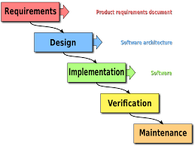
Requirement and analysis:

At this stage we will gather information about what the customer needs and define the problems the system is expected to solve. We will also gather requirement such as software like the programming language to use and hardware needed.

Design:
At this stage, we will make an overall design of the system architecture and physical design which includes user interface. It is at this stage that we will identify any faults before moving onto the next stage. The output of this stage is the design specification which is used in the next stage of implementation.

Coding/Implementation:
At this stage, we will begin coding as per the design specification. The output is one or more product components built according to a pre-defined coding standard and debugged, tested and integrated to satisfy the system architecture requirement.

Testing:
At this stage, I will ensure both individual and integrated which are methodically verified to ensure they are error free and satisfy customer requirement. I will involve individual code module, system testing of the integrated product and acceptance testing conducted by or on behalf of customer. I will ensure bugs found are corrected before moving to the next stage, I will also prepare review and publish product documentation at this stage.

Maintenance:
This stage occurs after installation. It involves modification on the system to improve performance. Such changes are use initiated or as a result of bug, being discovered which were initially not known. These modifications are recorded for documentation and system update.

Why I choose the model ??
- Simple and easy to understand and use
- Easy to manage due to the rigidity of the model. Each phase has specific deliverables and a review process.
- Phases are processed and completed one at a time.
- Works well for smaller projects where requirements are very well understood.
- Clearly defined stages.
- Well understood milestones.
- Easy to arrange tasks.
- Process and results are well documented.

Waterfall Model - Application

Every software developed is different and requires a suitable SDLC approach to be followed based on the internal and external factors. Some situations where the use of Waterfall model is most appropriate are −
- Requirements are very well documented, clear and fixed.
- Product definition is stable.
- Technology is understood and is not dynamic.
- There are no ambiguous requirements.
- Ample resources with required expertise are available to support the product.
- The project is short.

Chapter – 4
System Design

4.1 Introduction:
Design is the first step of the development phase of any engineered product or System. It is the most creative process of any product; a good design is the key of the effective system. In this System Design term we will talk about the process of applying various techniques and principles for the purpose of defining a process or a system in sufficient detail to permit its physical realization. In this phase we will discuss about all the Design process.

4.2 DATABASE STRUCTURE MODELING

In the database structure modeling, firstly we look forward to data of our system. Then we divided our data in 3 categories. That are-
- Static Data
- Semi Static Data
- Dynamic Data
- Static Data
Static data is data that does not change after being recorded. It is a fixed data set. In our system we used Static Data in CR_PANEL table. Such as ID, USERNAME, PASSWORD, E-MAIL, MOBILE this does not change.
- Semi Static Data
Semi Static is data that sometimes change after being recorded. In our system we used Semi Static Data in Contacts table. Such as- ID, NAME, E-MAIL, MOBILE, INTAKE_SECTION, ROOM_NO, TYPE, SHORT_CODE, CR_IDwhich sometimes change.

ID | INT(20) | NOT NULL | PRIMARY | ADMIN ID NUMBER
USERNAME | varchar(50) | NO |  | ADMIN USERNAME
PASSWORD | varchar(50) | NO |  | ADMIN PASSWORD
EMAIL | varchar(50) | NO |  | MAIL ADDRESS

Figure : CR_panel
Table 3.2.2: SCHEDULE
Field | Type | NULL | Key | Description
SERIAL_ID | INT(20) | AUTO_INCREMENT | Primary key | SERIAL ID
DATE | DATE |  |  | DATE
TIME | TIME(6) |  |  | TIME
COURSE_CODE | Varchar(20) |  |  | COURSE CODE
COURSE _TITLE | Varchar(20) |  |  | COURSE TITLE
ROOM _NO | INT (20) |  |  | ROOM NO
TYPE | Varchar(20) |  |  | TYPE
CR_ID | Int (20) | NOT NULL |  | CR_ID

Figure : Schedule table

4.3 TABLE STRUCTURE AND LIST WITH POPER DESCRIPTION

The next step is to lay out a visual representation of our database. To do this thing, we need to create tables with the help of our lists of data. After normalize our data we understand that we need four table for our recommended system. That are-
- CR_PANEL TABLE
In the CR_PANEL table, the primary key is ID and other attributes are USERNAME, PASSWORD, and E-MAIL & MOBLIE. Where CR using this attributes to login our system.
- CONTACTS TABLE
In this table, Student & Teacher Contacts numbers are stored. Where the primary key is ID and other attributes are NAME, E-MAIL, MOBILE, INTAKE_SECTION, ROOM_NO, TYPE, SHORT_CODE and CR_ID.
- SCHEDULE TABLE
In this table, Exam and Class schedule are stored. Where the primary keys are SERIAL_ID & CR_ID. And other attributes are DATE, TIME, C_CODE, C_TITLE, ROOM_NO and TYPE.

- NOTICE_BOARD TABLE
In this table where CR updates all notice. Where primary keys are SERIAL_NO and CR_ID. And others attribute are C_CODE, SUBMISSION_DAE, TOPICS, PUBLISH_DATE, TYPE, C_TITLE, & OTHERS.

ENTITY RELATIONSHIP

In this part, we discuss about Entity Relationship among all entities which we used to design our system.

First we see the relationship between CR_PANEL and NOTICE_BOARD

- Left to Right
One CR can compose a new notice at a time. This assigned to notice board.
- Right to Left
One notice has a notice_board. This is done by one CR.

Second we see the relationship between CR_PANEL and SCHEDULE

- Left to Right
One CR manages one Exam/Class schedule at a time. This assigned to Schedule.

- Right to Left
One Schedule has one Exam/Class schedule. Which will be developed by one CR.

Third we see the relationship between CR_PANEL and CONTACTS

- Left to Right
One CR adds one or many contacts info. Which is assigned to Contacts.

- Right to Left
Contacts generates to one or many Contact_Info. And Contact_Info is served by on CR.

Chapter – 5
Implementation Planning and Testing
5.1 Implementation Environment:
It is the phase where visions and plans become reality. This is the logical conclusion, after evaluating, deciding, visioning, planning, applying for funds and finding the financial resources of a project. Technical implementation is one part of executing a project.

5.2 System Implementation:
Systems implementation is the process of:
#defining how the information system should be built
#ensuring that the information system is operational and used.
#ensuring that the information system meets quality standard.
If all this process is successfully installed then we can say that the required system is perfectly implemented.
Several activities included also:
*End user training.
*End user education.
*Training on the application software.

5.3 Testing:
Software testing is an investigation conducted to provide stakeholders with information about the quality of the software product or service under test. Software testing can also provide an objective, independent view of the software to allow the business to appreciate and understand the risks of software implementation. Test techniques include the process of executing a program or application with the intent of finding software bugs, errors or other problems and verifying that the software product is fit for use.

5.4 Software Testing:
Software testing involves the execution of a software component or system component to evaluate one or more properties of interest. In general, these properties indicate the extent to which the component or system under test Software testing can provide objective, independent information about the quality of software and risk of its failure to users or sponsors.

Chapter – 6

DIAGRAMS

Log in process: First of all admin Log In process so admin take passward and user name then admin creat database .User match query with database.Return info.from database in log in process then admin log in confirm.

6.1 DFD
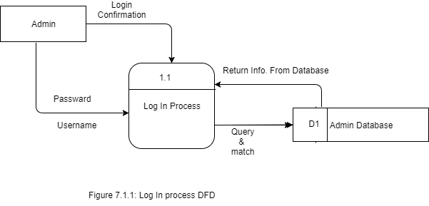

Update notice board: Admin/CR compose a new notice for update notice board.then creat notice board database so insert into database.Fedback from notice board database.Now admin/CR show notice

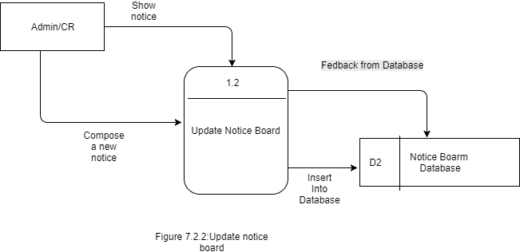

Get Schedule: Student/User select type for get schedule.Schedule database record fedback.Then user show schedule in web.

Browse contact: Student/User Browse contact info. For search for contact .Then contact database fedback record to browse contack info.Now student/user show contact in web.

Figure 6.4: Browse contact info

E-R diagram

Use case :

Chapter -7
Appendix

7.1 Screenshot of the project
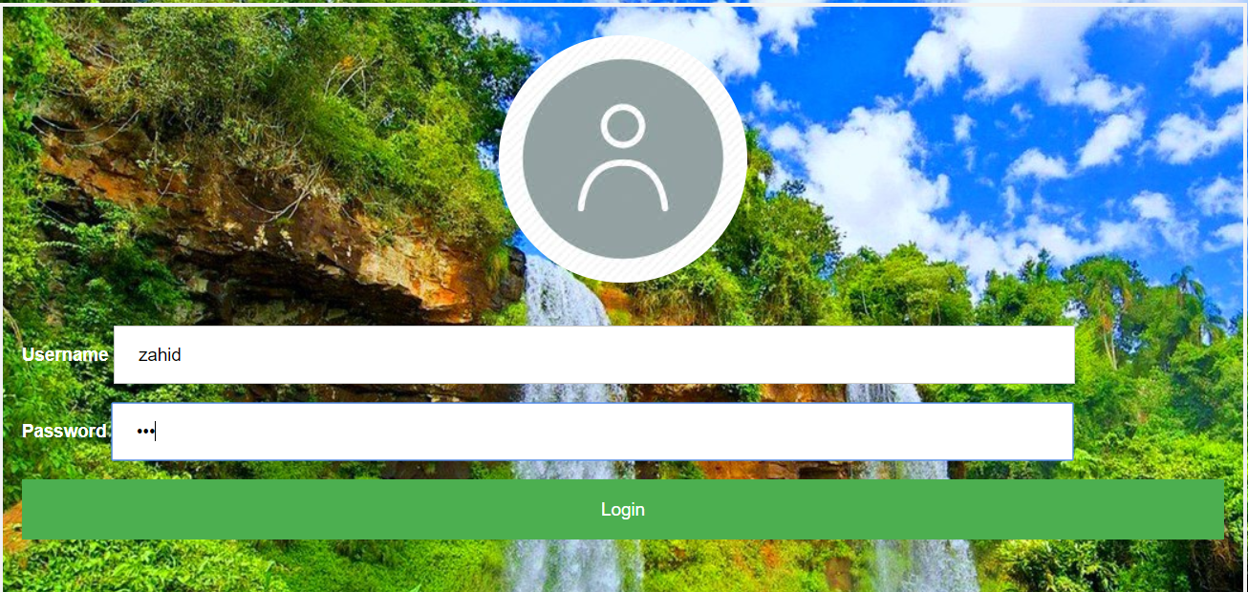

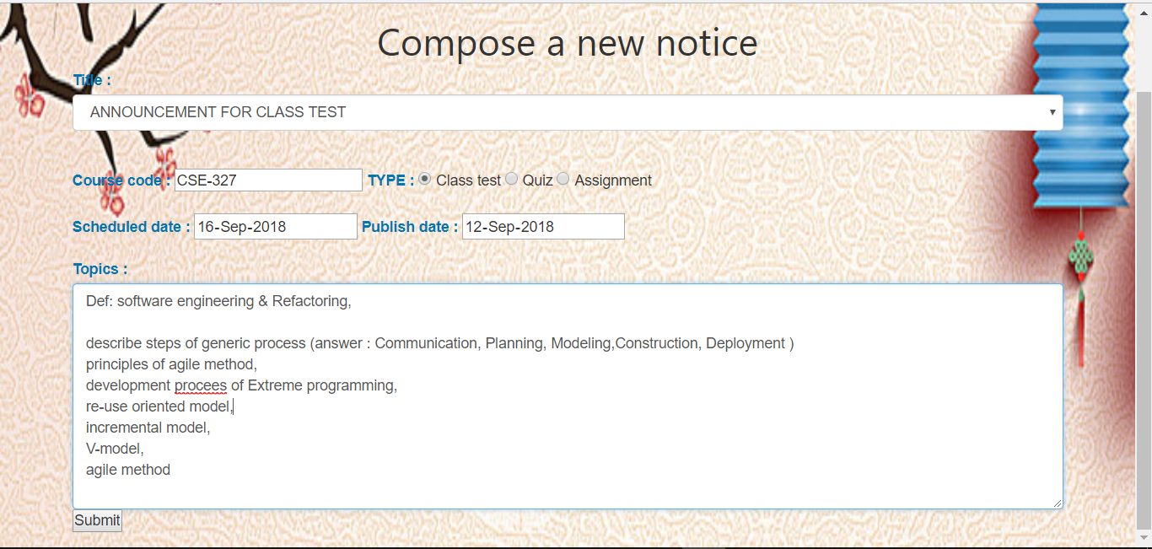

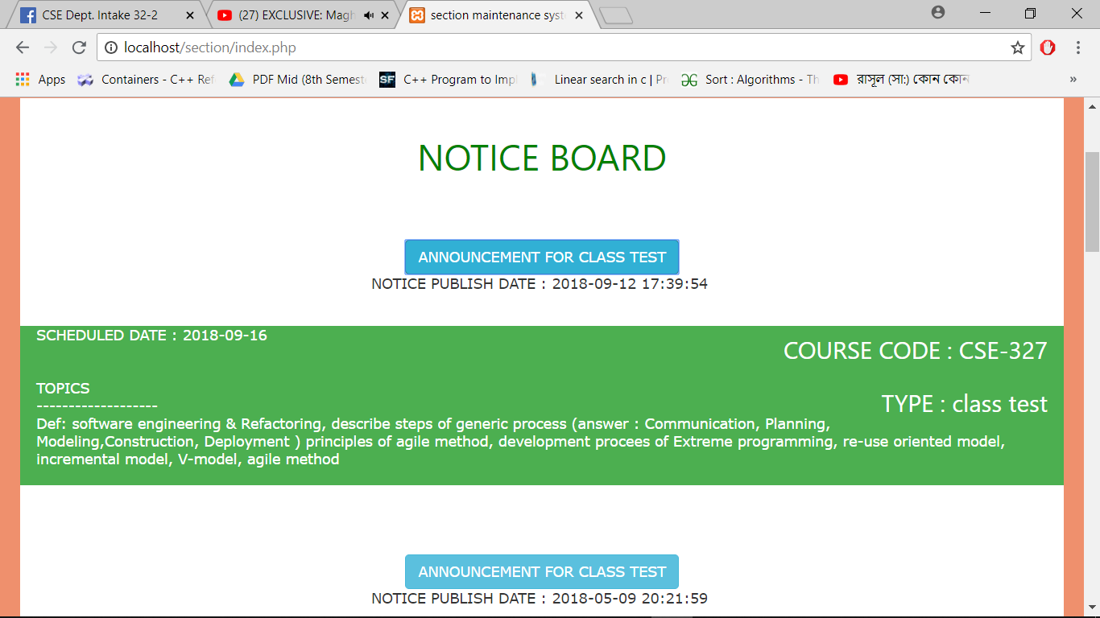
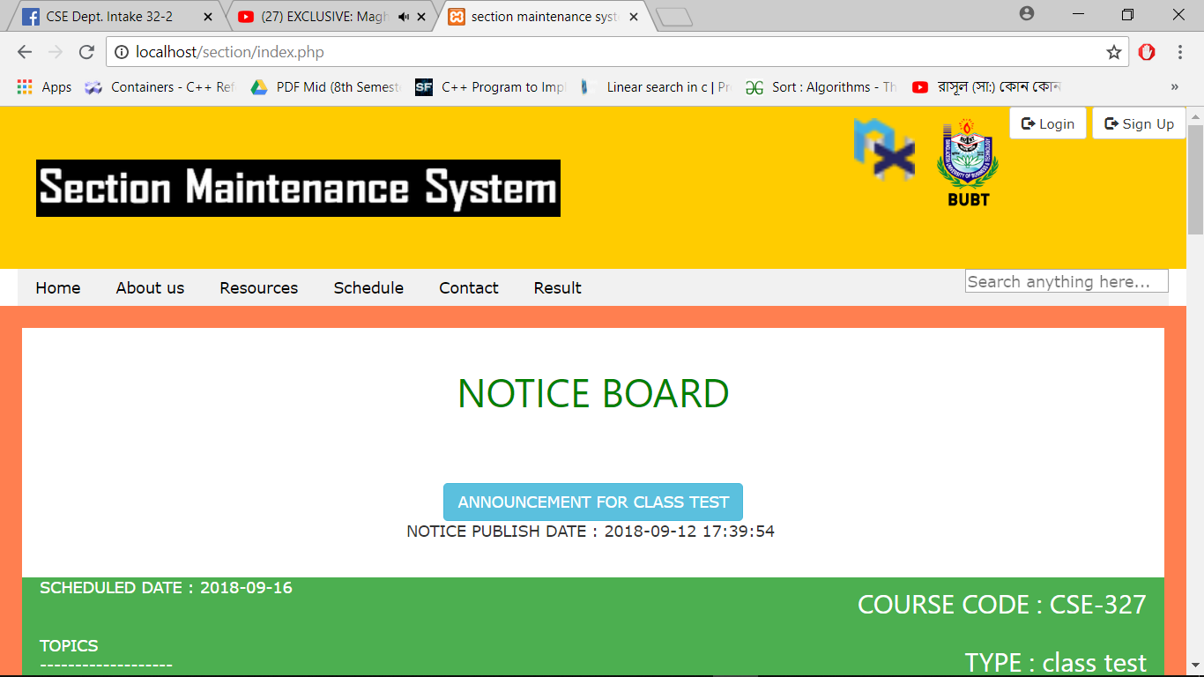

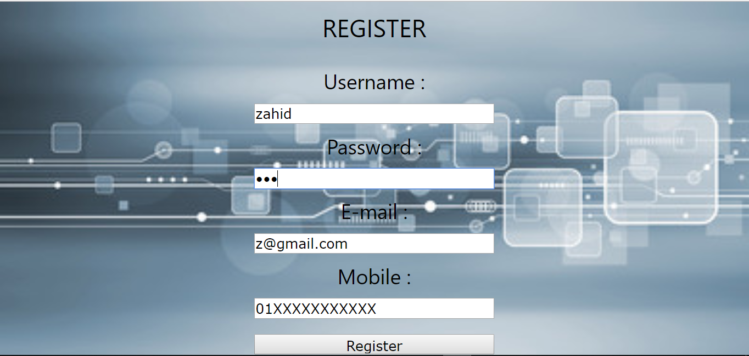

Conclussion& Discussion

The section of university can handle full-scale computer and computer related resource. The Section Management System deals with all the activities done by this web such as class schedule, examinations schedule, assignment submission information, contacts with course teacher etc all these process are handled by section management system.

FUTURE ENHANCEMENT
We think this project would help students so much and we also hope that we can improve this web in future.

- In the Future Student can also be able to upload or download notes.
- We will see the entire system more interactive and also be able to give statistics data.
- We can run the entire system in any operating system and also we have an android/IOS application of this entire system.

References:
- https://www.google.com
- http://www.w3schools.com
- https://www.tutorialspoint.com/dbms/dbms_data_models.htm
- https://www.phptpoint.com/
- Wikipedia

